Updates:
Date | Update (highlighted in blue)
09/03/2024 | Update to how LXDV is to handle issues with these guidelines, the Vocabulary Tracker, and the addition and relabeling of terms.

Vocabulary Guidelines:

Defining Vocabulary within Lesson – Student Edition
- Reference the Vocabulary Tracker to determine if the vocabulary term should be treated as new or review.
- Yellow highlight and bold new terms
- Review vocabulary is neither highlighted nor bold.
- Please reach out to HMH LXD via the Issue Tracker and/or email if you encounter issues with these guidelines, need a term added to the Vocabulary Tracker, or need a term relabeled as “New” or “Review”.
- If as the result of editing or writing new content, a vocabulary term now occurs in a lesson that is not documented in the Vocabulary Tracker, please add to vocabulary tracker and make the fill for the new vocabulary term’s cell a bright yellow.
  - If the vocabulary term was already in that grade, insert a row in the lesson the vocabulary term is being added to, then copy and paste from the other occurrence of the term in the vocabulary tracker. Update the lesson information. The Instance column will automatically update. Then make sure all other instances of the vocabulary term in that grade level are updated to ‘review’.
  - If the vocabulary term was not used previously in that grade, insert a row in the lesson the vocabulary term is being added to, then add in the grade #, V2 Lesson # and definition. The Instance column will automatically update.
- For pickup change "Connect to Vocabulary" to "Vocabulary"
- Note: Grade K does not show vocabulary on the SE page so this section does not apply to Grade K

V1 has three approaches vocab was defined.
For V2 SE, define the vocabulary term using the approach that is used for V1 for this vocabulary term
- In a box  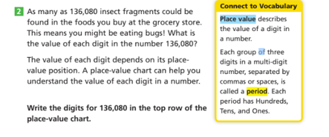 | - In running text before a task  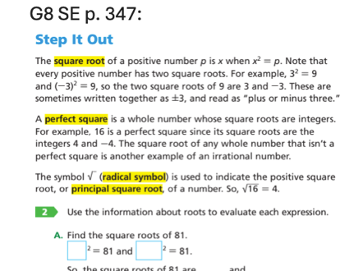 | - Within a task.

If you are adding a new vocabulary term to a lesson or are writing new content that doesn’t have a V1 source lesson, you will have to choose which vocabulary approach from above (A, B, or C) to use.
- First choice is A. In a box, if there is room on the page for it.
- If adding the box will cause overset, choose between B. In running text before a task and C. Within a task. Choose the option that makes the most sense for the content and the flow of the task.

Defining Vocabulary within Lesson – Teacher Edition
Vocabulary Terms will be mentioned in the Teacher Guide content in the Teacher Edition. Please see the EMM Guidelines; Task Section; Teacher Notes Subsection for details.

Module Opener: Vocabulary
List ALL new vocabulary terms and TWO High-Utility words for every module. In the EMM, the text in the left column is boilerplate and has already been populated in the EMM template. The vocabulary terms, high utility terms, and MLRs need to be populated in the EMM template by the LXDv. See High-utility words guidance below for populating the high utility terms bullets.

How this section appears in the print TE pages:
Use Words to Learn (WTL) routine in Classcraft or with the module’s WTL Vocabulary Cards to help students master any review terms and the following new terms:
- [add vocab term here] (Lesson x.y)
- [add vocab term here] (Lesson x.y)
Consider using the same routines to support students in mastering these high-utility words:
- [high utility term here] (Lesson x.y)
- [high utility term here] (Lesson x.y)

If a module does not have new vocabulary terms:
- Enter N/A in place of the bulleted list
- Update the boilerplate in the first row by deleting “and the following new terms” so the boilerplate should now read: "Use Words to Learn (WTL) in Classcraft or with the module’s WTL Vocabulary Cards to help children master any review terms."

High-utility words guidance
Two High-utility words have been selected for each module using the existing v1 lessons and documented in the High-Utility Words Tracker.
New high-utility words will need to be selected for modules that contain new lessons and have blank spaces in the tracker. Use the directions below to select high-utility words for the new lesson, then document the chosen high-utility words in the High-Utility Words Tracker.

When selecting high-utility words from new lessons, consider the following:

- High-utility words are “Tier 2” words that are likely to come up in school settings and instruction lines, and might not be commonly used in everyday conversation.
- These words are non-math specific.
- Look to the Learning Goals “I can” statements and to SE instruction lines for possible word choice.
- Do not repeat a high-utility word that has already been used within the grade level.
- Use the list below as a reference for high-utility words. **This is not an extensive list.
Examples of High-Utility/Tier 2 Words

adapt  advantages  affects  analyze  appearance  apply  approximate  argue  arrange  assess  associate  build  calculate  categorize  characteristics  check  claim  classify  combine  communicates  compare  compute  conclude  conditions  confirm  consider  construct  contrast  convert  critique  decide  decompose | deduce  defend  define  demonstrates  derive  design  determine  develop  diagram  differentiate  differs  disagree  distinguish  estimate  evaluate  evidence  examine  expand  experiment  explain  explore  figure out  find out  form  function  gauge  generate  identify  illustrates  imagine  impact  improve | infer  integrate  interpret  involves  justify  label  list  located  map  match  materials  measure  model  modify  navigate  notice  observe  opportunity  oppose  organize  outcome  persevere  persuade  plan  predict  process  produce  proves  purpose  qualify  quantify  question | rearrange  reason  recall  recognize  record  refer  reflect  reinforces  relate  repeat  represent  respond  resulted  revise  rewrite  select  shape  share  simplify  solve  sort  specify  statement  structures  study  substitute  summarize  supports  test  transform  translate  update  verify

Module Closer: Module Review - Vocabulary section
When a module has new vocabulary terms listed in the Vocabulary Tracker, a Vocabulary section is included on the Module Review page before the Concepts and Skills section.

G1–A1 (See Module Closer Guidelines section for additional information.)

For Module Reviews that have WOLs in print and require a Word Bank, list ALL new vocabulary terms for every lesson in the section labeled [Vocabulary Box]. The text, Use vocabulary words to complete the sentences., that has already been populated in the section above the Vocabulary Box is boilerplate.

For all Word Banks in print, be sure there is parity with the digital pattern.

Due to spacing, all new terms will not be represented as an item in the Vocabulary section. Only 2–5 vocabulary items can be authored. Those 2–5 terms should reflect the most critical content for the module.

If the module has only one new term, then choose at least one review term as a distractor for the Word Bank.

If there are no new vocab terms for the module, then type "N/A" in the Vocabulary Box as well as in the Item # and Learnosity Item Type columns under the Vocabulary section.

If the Vocabulary item type is line matching in print, the digital pattern is “Match List” in digital, and a Word Bank is not included for either component. In this case, enter N/A in the Vocabulary Box section of the EMM.

GK (See Kindergarten Considerations section for additional information.)

The Vocabulary section may include one problem, although multiple new vocabulary terms may be represented within that same problem.

The vocabulary word should be represented as an image. Students are using their understanding of the word to answer a question.

Problems in the Vocabulary section should be included in the TE Data-Driven Instruction table for GK.

If there are no new vocab terms for the module, then type "N/A" in the Item # and Learnosity Item Type columns under the Vocabulary section.

